**Experiment 1**

Aim: Install Apache Hadoop.

**Theory:**

Apache Hadoop is a powerful framework designed for the distributed storage and processing of large datasets using clusters of commodity hardware. Its integration with Ubuntu provides a stable and efficient environment for big data processing. Here’s how Hadoop relates to Ubuntu:

1. **Installation** – Apache Hadoop can be installed on Ubuntu by downloading the official Hadoop binaries or using package managers like apt. Ubuntu’s robust package management system simplifies the setup of Hadoop clusters.
2. **Compatibility** – Hadoop runs smoothly on Ubuntu servers and desktops without major compatibility issues, allowing users to leverage Ubuntu’s stability and efficiency for big data processing.
3. **Resource Management** – Ubuntu offers various tools for managing system resources, which is crucial when running Hadoop clusters. Proper resource management ensures optimal performance and efficient utilization of cluster resources.
4. **Security** – Ubuntu provides strong security features, including firewall configurations, user permissions, and encryption, which help secure Hadoop clusters and protect stored and processed data.
5. **Maintenance** – With its regular updates and long-term support (LTS) releases, Ubuntu ensures the stability and security of Hadoop clusters over extended periods. Updates can be easily applied to both Ubuntu and Hadoop components for seamless operation.
6. **Community Support** – Both Hadoop and Ubuntu have active communities that offer extensive documentation, troubleshooting resources, and support, making it easier for users to resolve issues and stay updated with new developments.

By using Ubuntu as the operating system for Hadoop, users can take advantage of its reliability, security, and ease of maintenance to build scalable and efficient big data processing systems.

Steps:

1. Install Hadoop in the virtual machine.

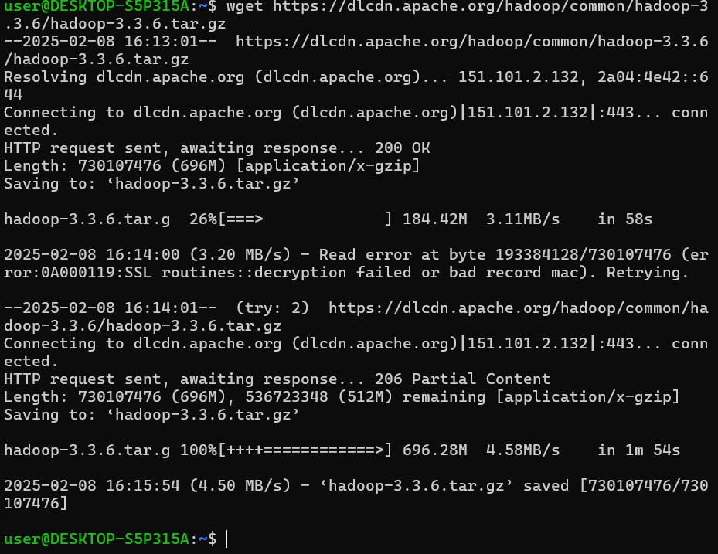

2. Unzip Hadoop

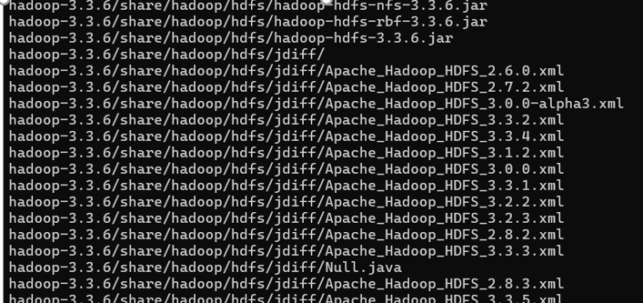

3. Setup environment variables

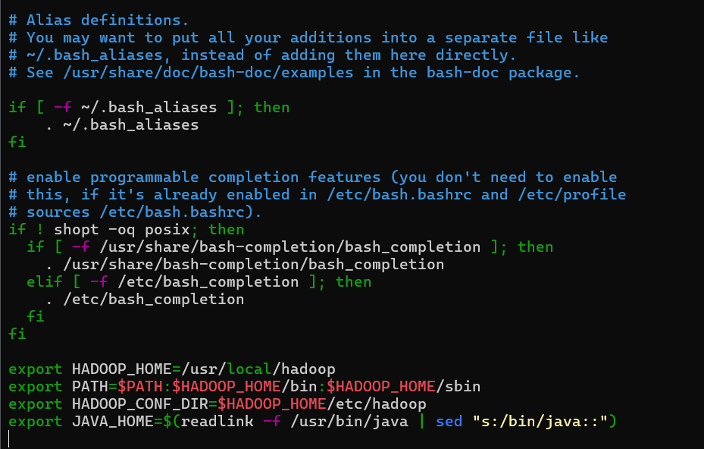

4. Download Java SE Development Kit

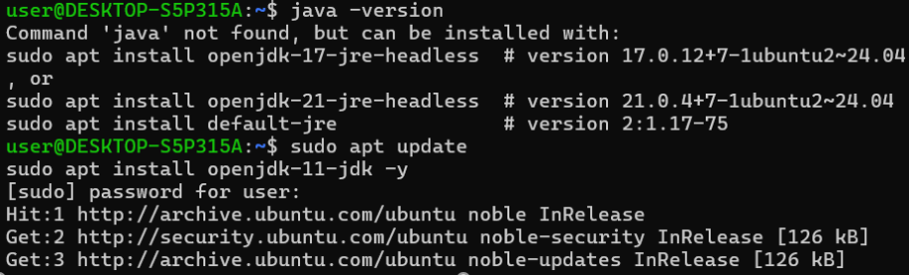

5. Configure hadoop

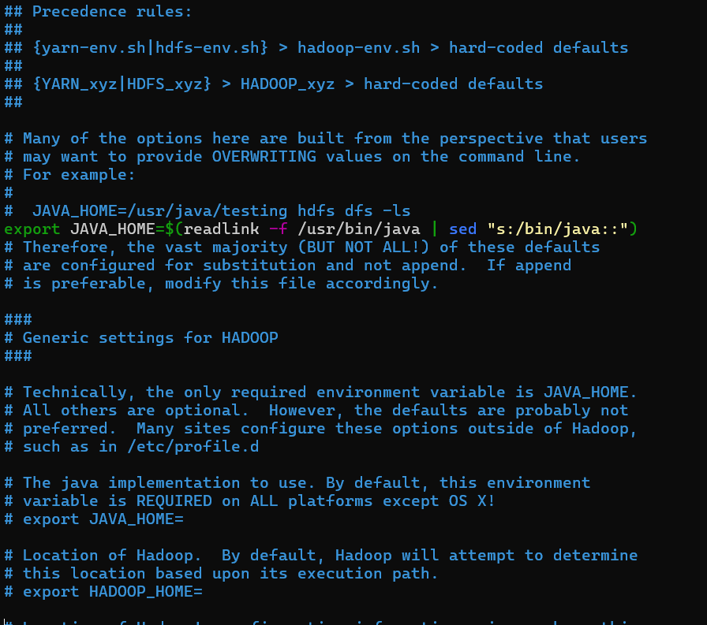

6. Check Hadoop version.

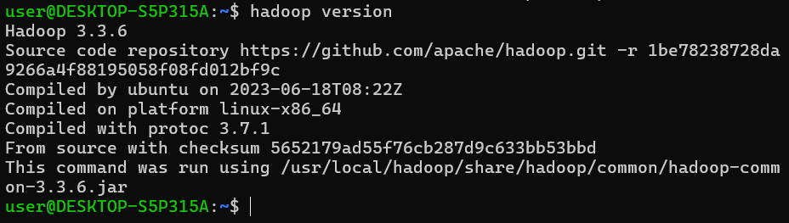

**Learning Outcome**

**Experiment 2**

**Aim**: Develop a mapreduce program to calculate the frequency of a given word in a given file.

**Theory**

This experiment focuses on developing a MapReduce program using Apache Hadoop to efficiently compute the frequency of a specified word within a given text file. MapReduce is a programming model designed for processing large datasets in a distributed manner. By utilizing Hadoop's parallel processing capabilities, this approach enables efficient text analysis and provides insights into word frequency.

Word frequency analysis is a key task in natural language processing (NLP), involving the determination of how often each word appears in a document or corpus. Apache Hadoop offers a scalable framework for distributed computing, making it well-suited for parallel processing tasks like MapReduce. This experiment employs the MapReduce paradigm to distribute the workload across multiple nodes in a Hadoop cluster, significantly enhancing the speed and efficiency of text data analysis.

The primary objective of this experiment is to develop and implement a MapReduce program that calculates the frequency of a given word in a text file. By distributing computations across multiple nodes, this experiment highlights the scalability and efficiency of Hadoop in handling large-scale text processing tasks.

Ultimately, the experiment showcases the effectiveness of Apache Hadoop and the MapReduce framework in processing big data. By leveraging distributed computing, Hadoop enables efficient and scalable word frequency analysis, making it applicable to various domains requiring large-scale data processing.

**Steps**

Check Hadoop version



Create folder named wordcount



Install JDK

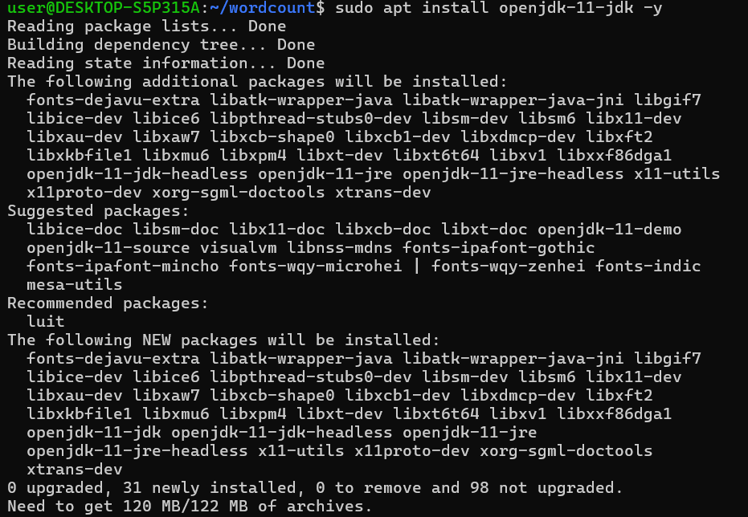



**Code of WordCount.java file**

import org.apache.hadoop.conf.Configuration;

import org.apache.hadoop.fs.Path;

import org.apache.hadoop.io.IntWritable;

import org.apache.hadoop.io.Text;

import org.apache.hadoop.mapreduce.Job;

import org.apache.hadoop.mapreduce.Mapper;

import org.apache.hadoop.mapreduce.Reducer;

import org.apache.hadoop.mapreduce.lib.input.FileInputFormat;

import org.apache.hadoop.mapreduce.lib.output.FileOutputFormat;

import java.io.IOException;

import java.util.StringTokenizer;

public class WordCount {

public static class TokenizerMapper extends Mapper<Object, Text, Text, IntWritable> {

private final static IntWritable one = new IntWritable(1);

private Text word = new Text();

public void map(Object key, Text value, Context context) throws IOException, InterruptedException {

StringTokenizer itr = new StringTokenizer(value.toString());

while (itr.hasMoreTokens()) {

word.set(itr.nextToken());

context.write(word, one);

}

}

}

public static class IntSumReducer extends Reducer<Text, IntWritable, Text, IntWritable> {

private IntWritable result = new IntWritable();

public void reduce(Text key, Iterable<IntWritable> values, Context context) throws IOException, InterruptedException {

int sum = 0;

for (IntWritable val : values) {

sum += val.get();

}

result.set(sum);

context.write(key, result);

}

}

public static void main(String[] args) throws Exception {

Configuration conf = new Configuration();

Job job = Job.getInstance(conf, "word count");

job.setJarByClass(WordCount.class);

job.setMapperClass(TokenizerMapper.class);

job.setCombinerClass(IntSumReducer.class);

job.setReducerClass(IntSumReducer.class);

job.setOutputKeyClass(Text.class);

job.setOutputValueClass(IntWritable.class);

FileInputFormat.addInputPath(job, new Path(args[0]));

FileOutputFormat.setOutputPath(job, new Path(args[1]));

System.exit(job.waitForCompletion(true) ? 0 : 1);

}

}

Compile java program



Create jar file



Copy the input file to Hadoop's HDFS:

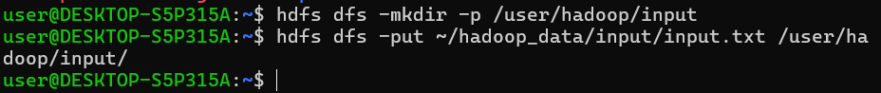

Run the MapReduce Job

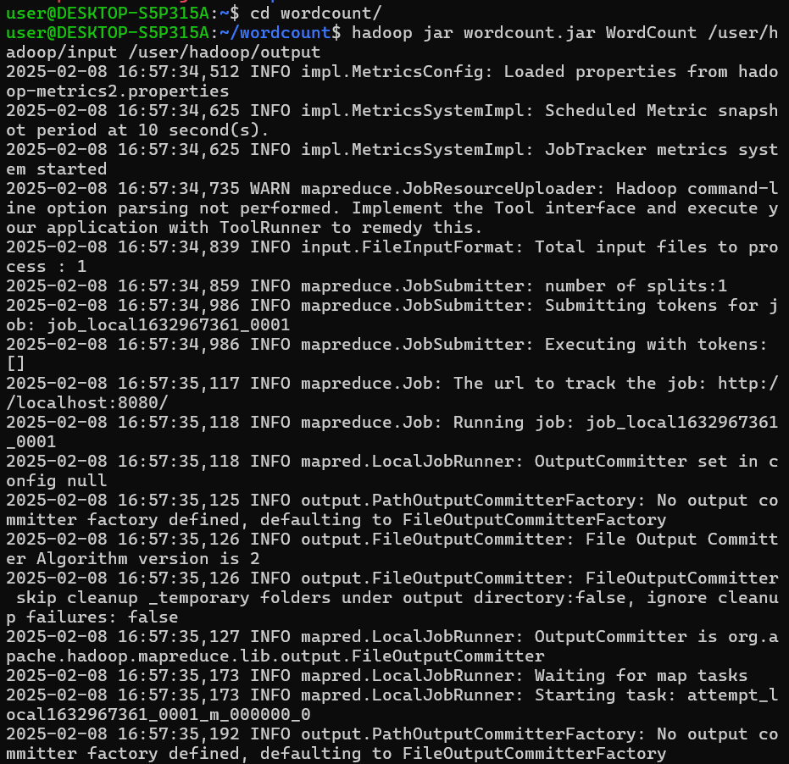

Check the output directory and Retrieve and display the word count:

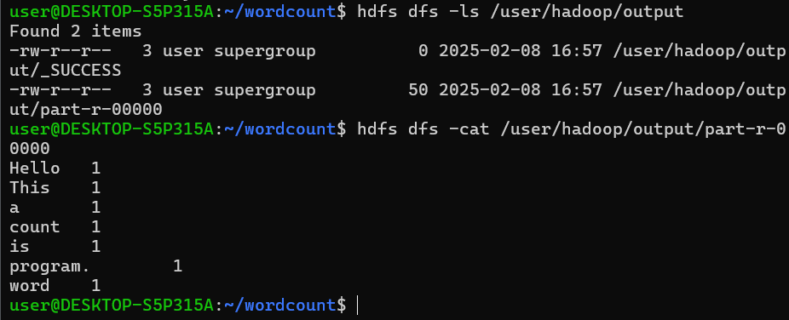

**Learning Output**

**Experiment 3**

**Aim**: Develop a MapReduce program to find the grade of students.

**Theory:**

The aim of this MapReduce program is to process student scores and assign grades based on predefined score ranges. The program will take input in the form of student names and scores, then calculate each student's grade using a grading scale: A (90-100), B (80-89), C (70-79), D (60-69), and F (below 60). The MapReduce framework is ideal for this task because it can efficiently handle large datasets by distributing the processing across multiple machines, ensuring scalability and faster computation.

In the MapReduce process, the mapper will read each student’s score, determine the corresponding grade, and emit key-value pairs (student name, grade). The reducer will aggregate the results, ensuring each student's name is paired with their respective grade in the final output. This approach allows for parallel processing of large datasets, and the Hadoop framework ensures fault tolerance, making it a robust solution for determining grades across vast amounts of student data.

**Steps**

Create directories:



Create Java file:

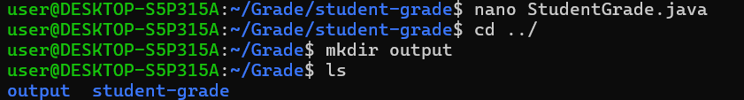

**Java Code:**

import org.apache.hadoop.conf.Configuration;

import org.apache.hadoop.fs.Path;

import org.apache.hadoop.io.Text;

import org.apache.hadoop.mapreduce.Job;

import org.apache.hadoop.mapreduce.Mapper;

import org.apache.hadoop.mapreduce.Reducer;

import org.apache.hadoop.mapreduce.lib.input.FileInputFormat;

import org.apache.hadoop.mapreduce.lib.output.FileOutputFormat;

import java.io.IOException;

public class StudentGrade {

public static class GradeMapper extends Mapper<Object, Text, Text, Text> {

public void map(Object key, Text value, Context context) throws IOException, InterruptedException {

String[] parts = value.toString().split(",");

if (parts.length == 2) {

String studentName = parts[0].trim();

double score = Double.parseDouble(parts[1].trim());

String grade;

if (score >= 90) {

grade = "A";

} else if (score >= 80) {

grade = "B";

} else if (score >= 70) {

grade = "C";

} else if (score >= 60) {

grade = "D";

} else {

grade = "F";

}

context.write(new Text(studentName), new Text(grade));

}

}

}

public static class GradeReducer extends Reducer<Text, Text, Text, Text> {

public void reduce(Text key, Iterable<Text> values, Context context) throws IOException, InterruptedException {

for (Text val : values) {

context.write(key, val);

break;

}

}

}

public static void main(String[] args) throws Exception {

if (args.length != 2) {

System.err.println("Usage: StudentGrade <input path> <output path>");

System.exit(-1);

}

Configuration conf = new Configuration();

Job job = Job.getInstance(conf, "Student Grade Calculation");

job.setJarByClass(StudentGrade.class);

job.setMapperClass(GradeMapper.class);

job.setReducerClass(GradeReducer.class);

job.setOutputKeyClass(Text.class);

job.setOutputValueClass(Text.class);

FileInputFormat.addInputPath(job, new Path(args[0]));

FileOutputFormat.setOutputPath(job, new Path(args[1]));

System.exit(job.waitForCompletion(true) ? 0 : 1);

}

}

Create input file:



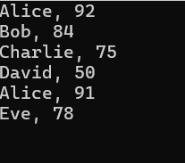

Compile java file and Jar file:

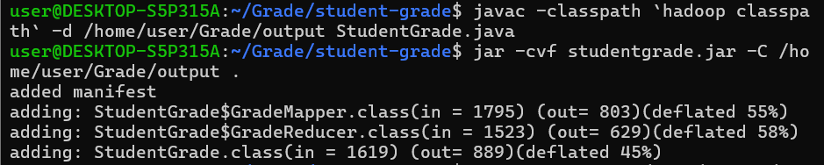

**Create the output directory** in HDFS (Hadoop File System):



**Upload the input file to HDFS:**



**Run the MapReduce job** using the following command:

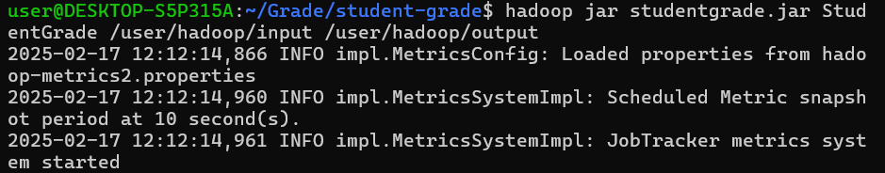

Check the Output:

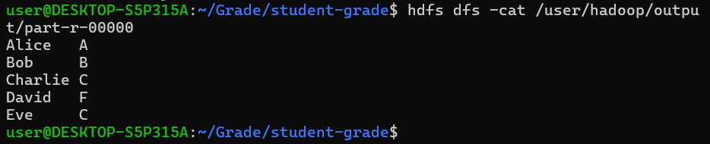

**Learning Outcome**